 Kernel -trick in SVM

Support Vector Machine deals with nonlinear data by transforming it into a higher dimension where it is linearly separable. Support Vector Machine does so by using different values of Kernel. We have various options available with kernel like, ‘linear’, “rbf”, ”poly” and others (default value is “rbf”). Here “rbf” and “poly” are useful for non-linear hyper-plane.

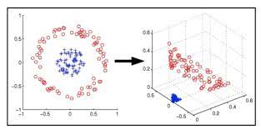

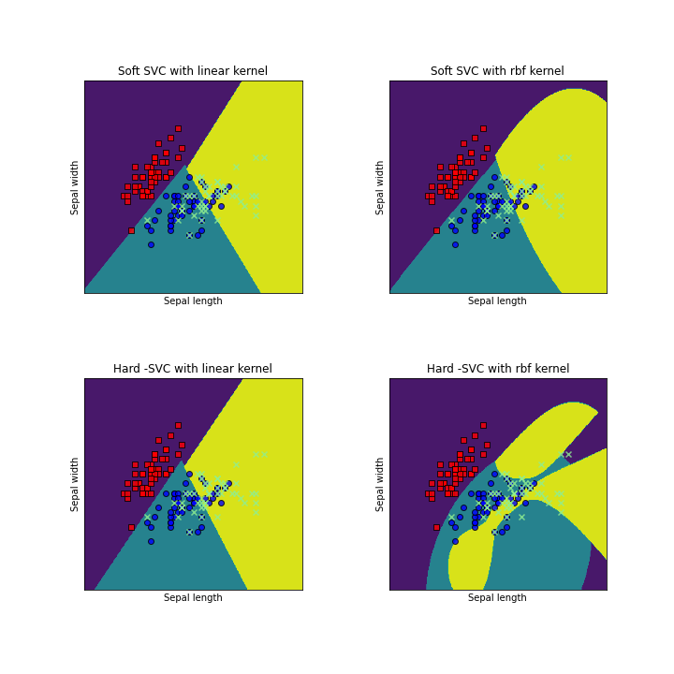

From the above figure, choosing the right kernel is very important in order to get the correct results.